**Module 2**

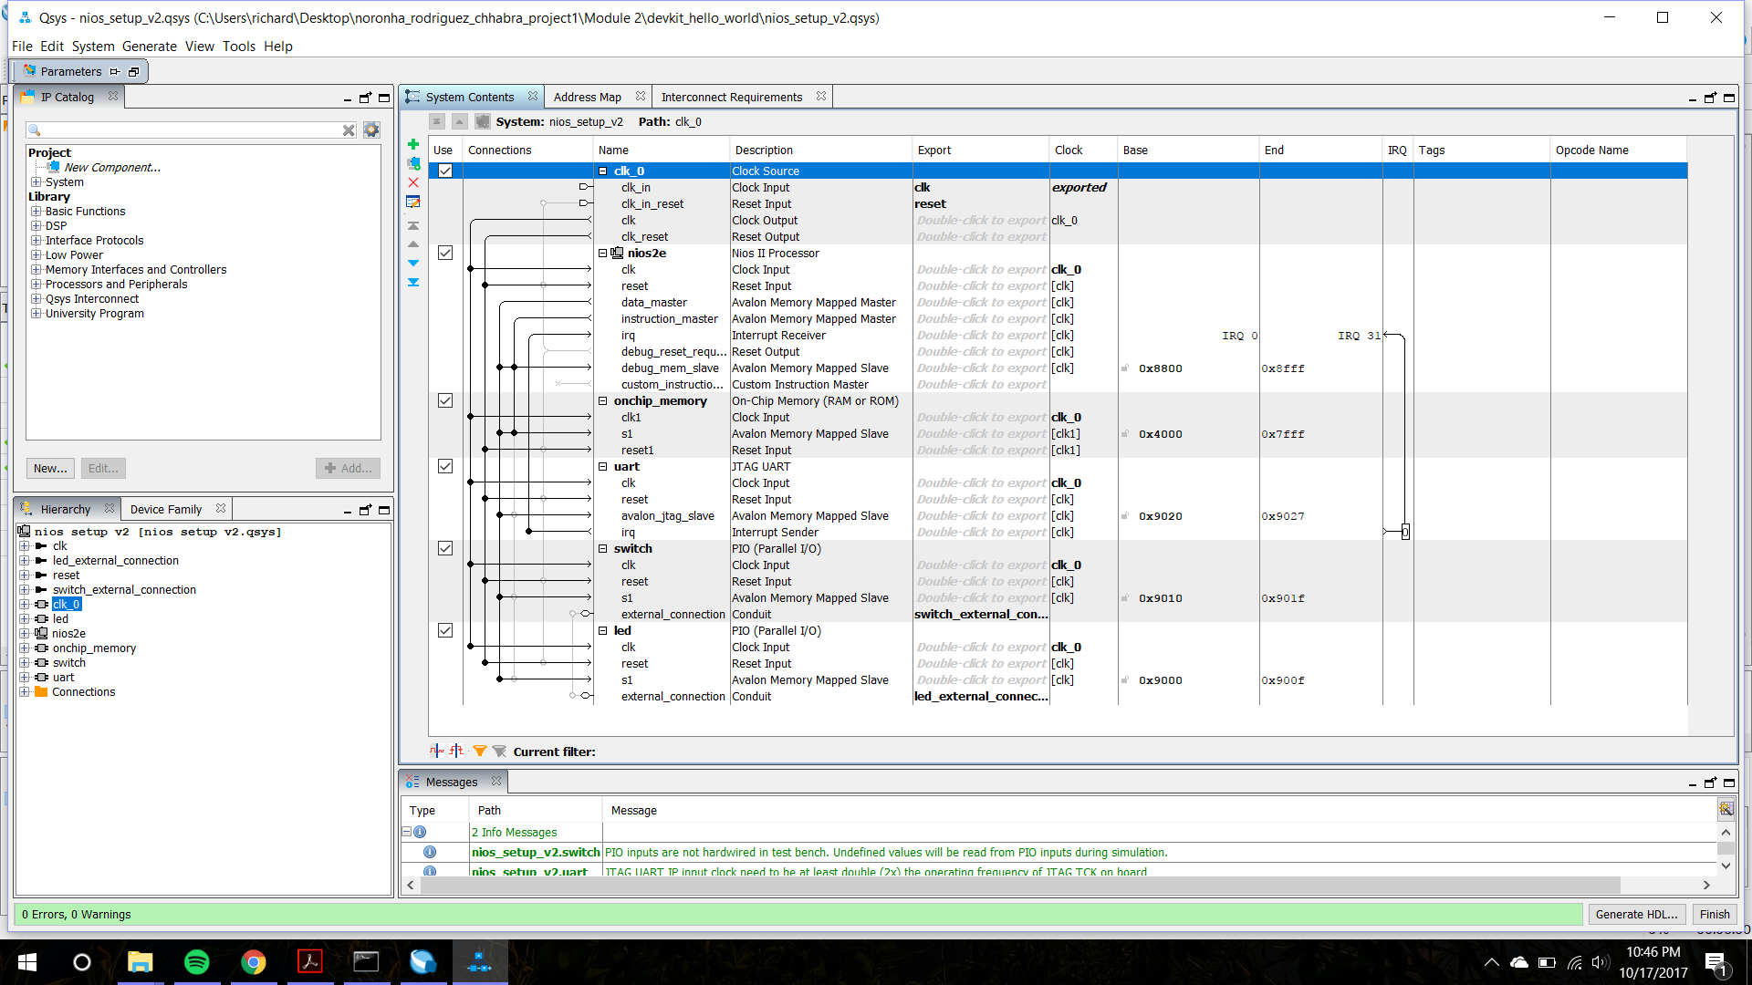

Fig 1. Qsys connections

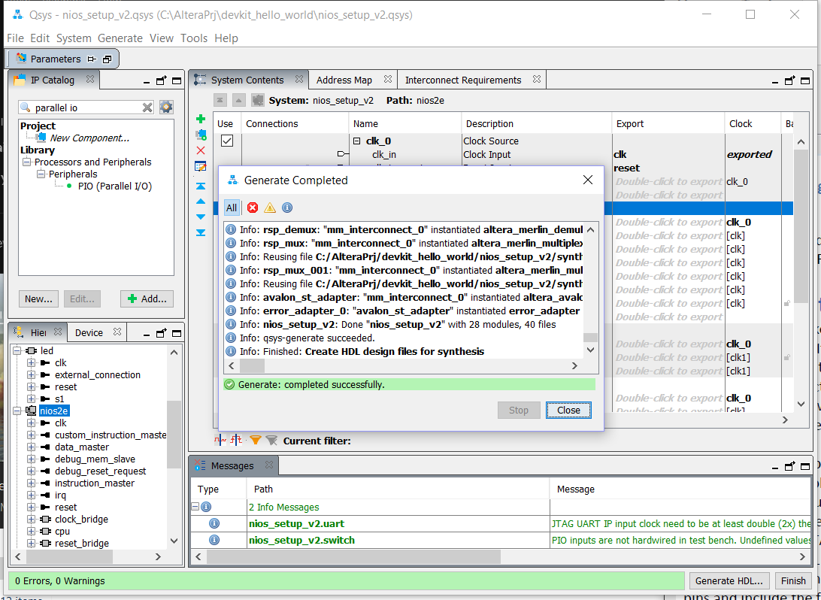

Fig 2. Successful generation of the HDL code

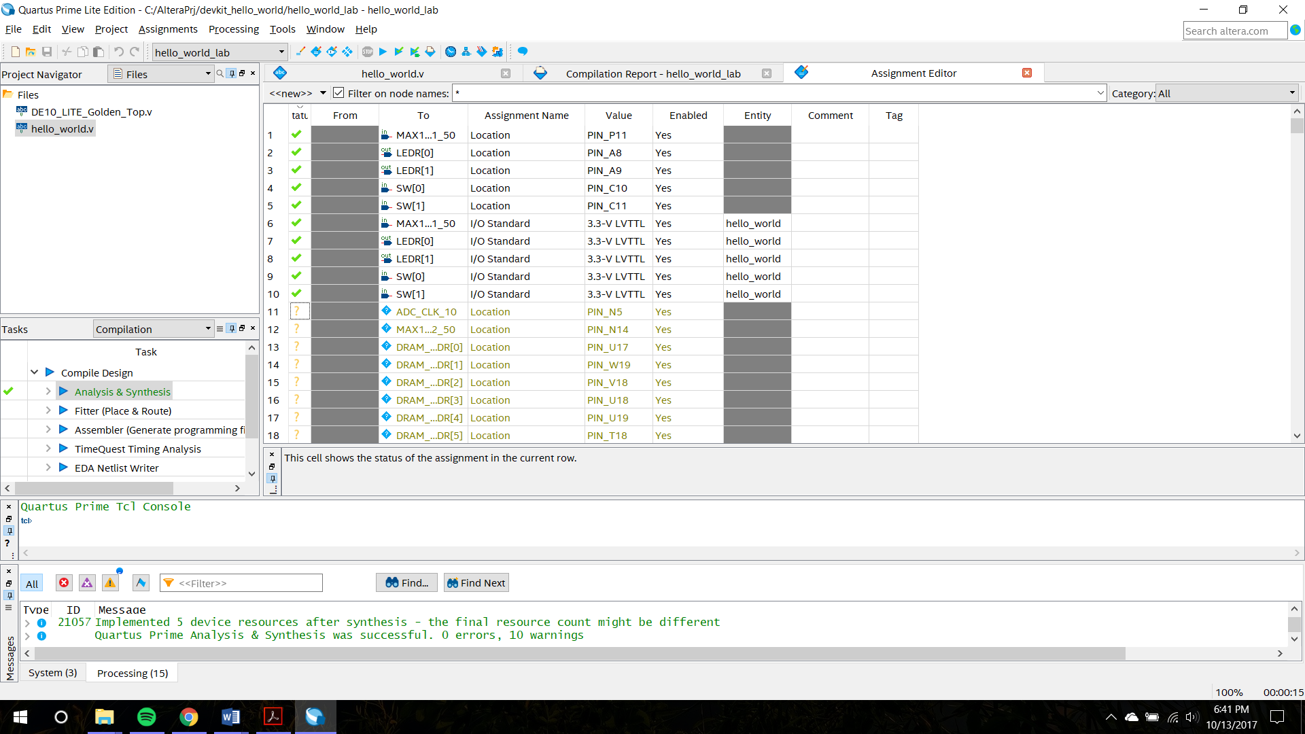

Fig 3. The assignment of the various pins in the module

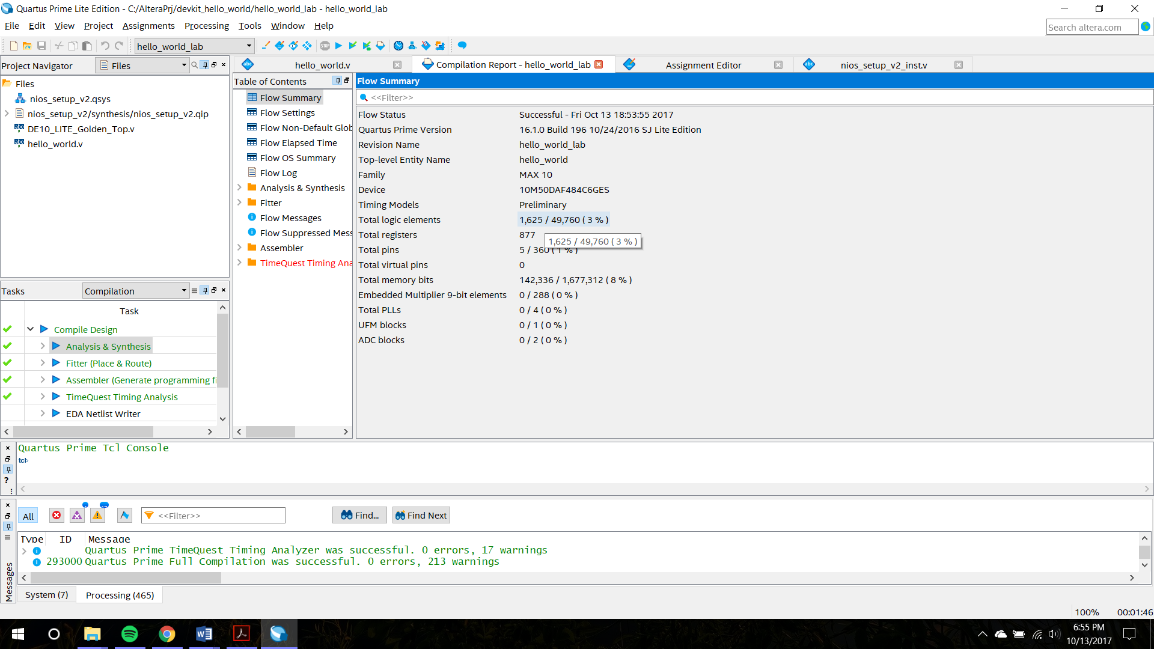

Fig 4. Successful compilation report

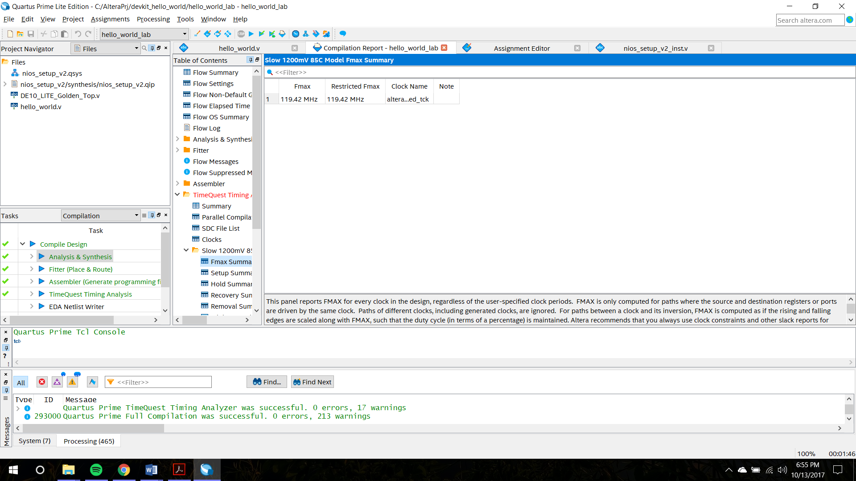

Fig 5. Fmax

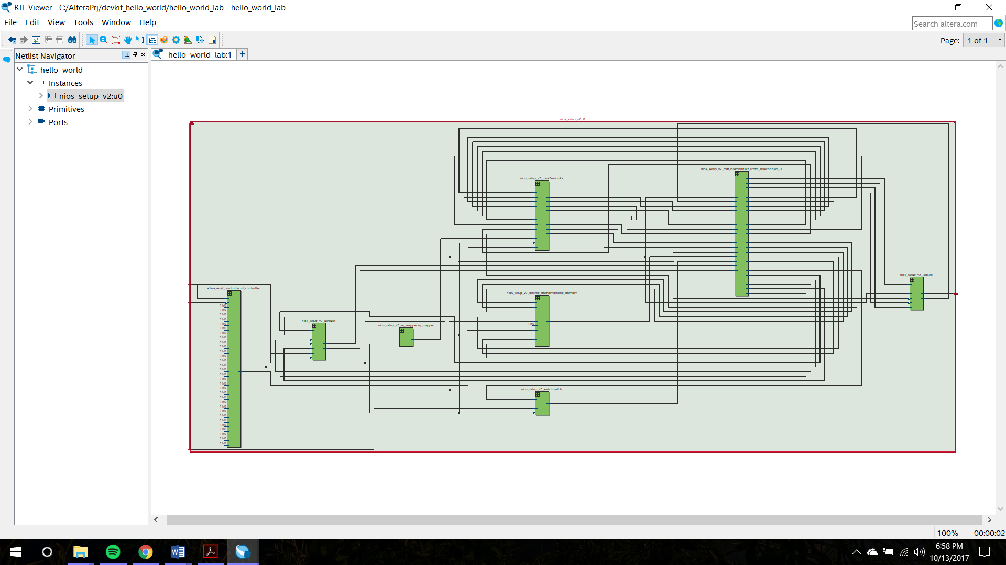

Fig 6 RTL for module 2

**Software design**

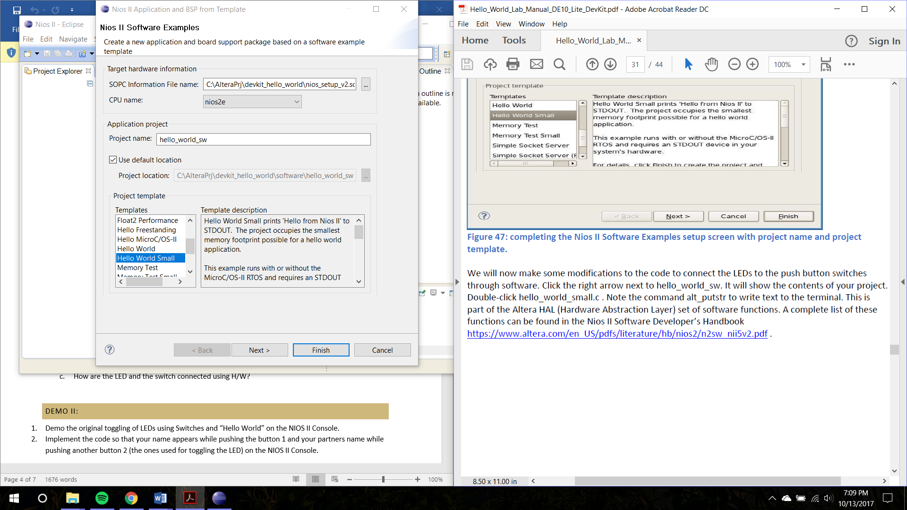

Fig 7. Setting up the software

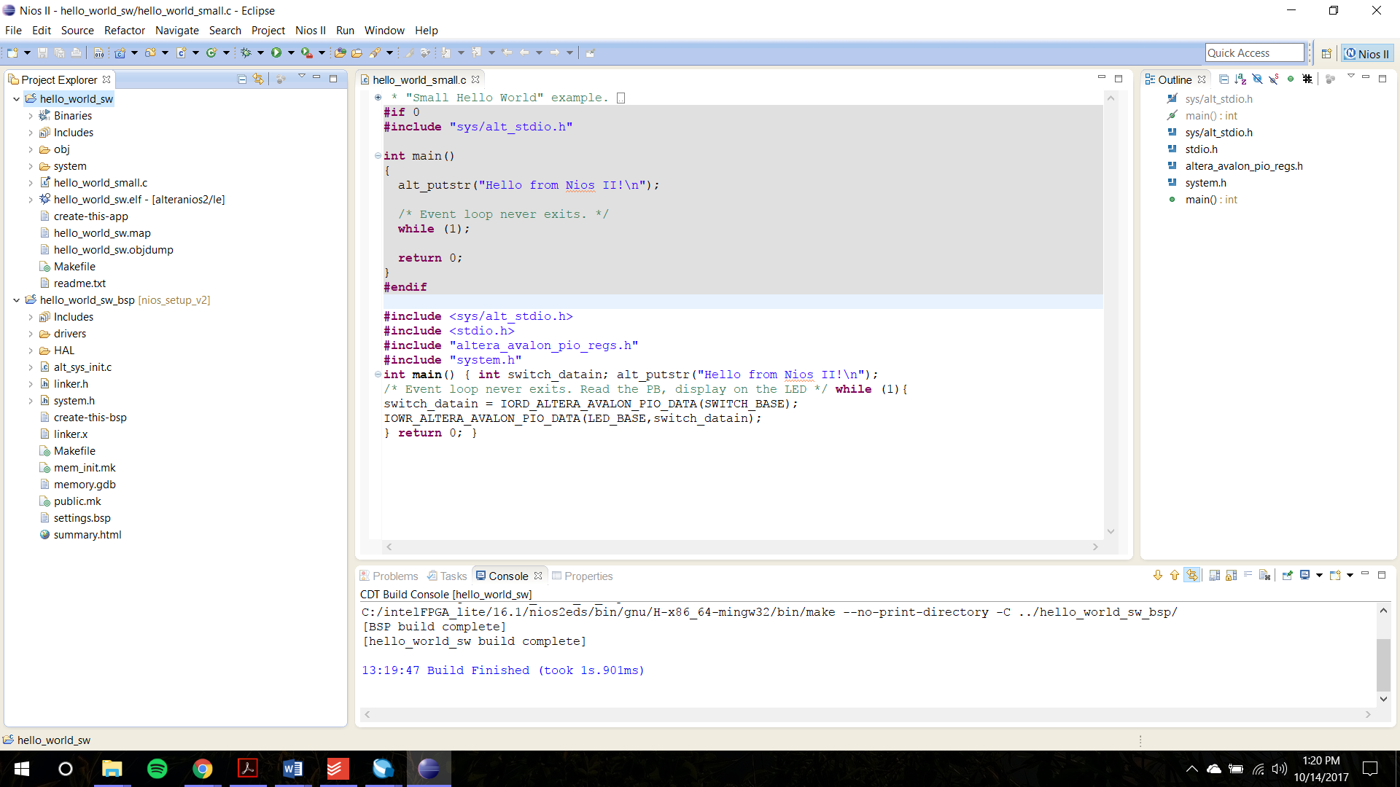

Fig 8. Successful build of the C Code

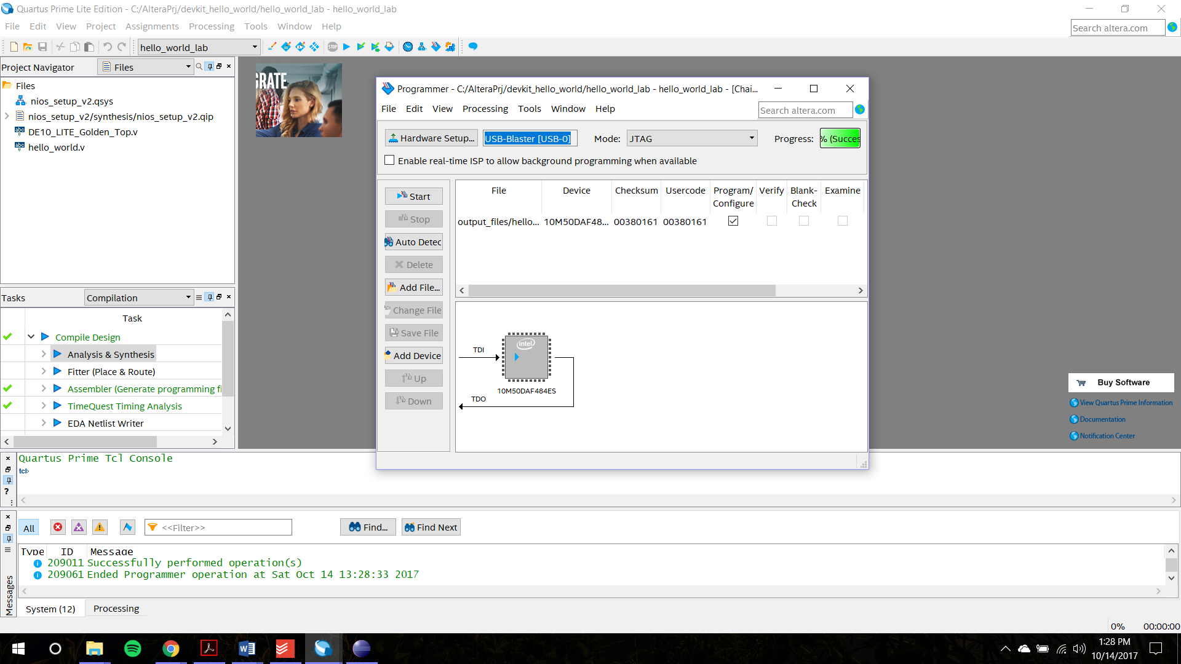

Fig 9. Programming the De10Lite

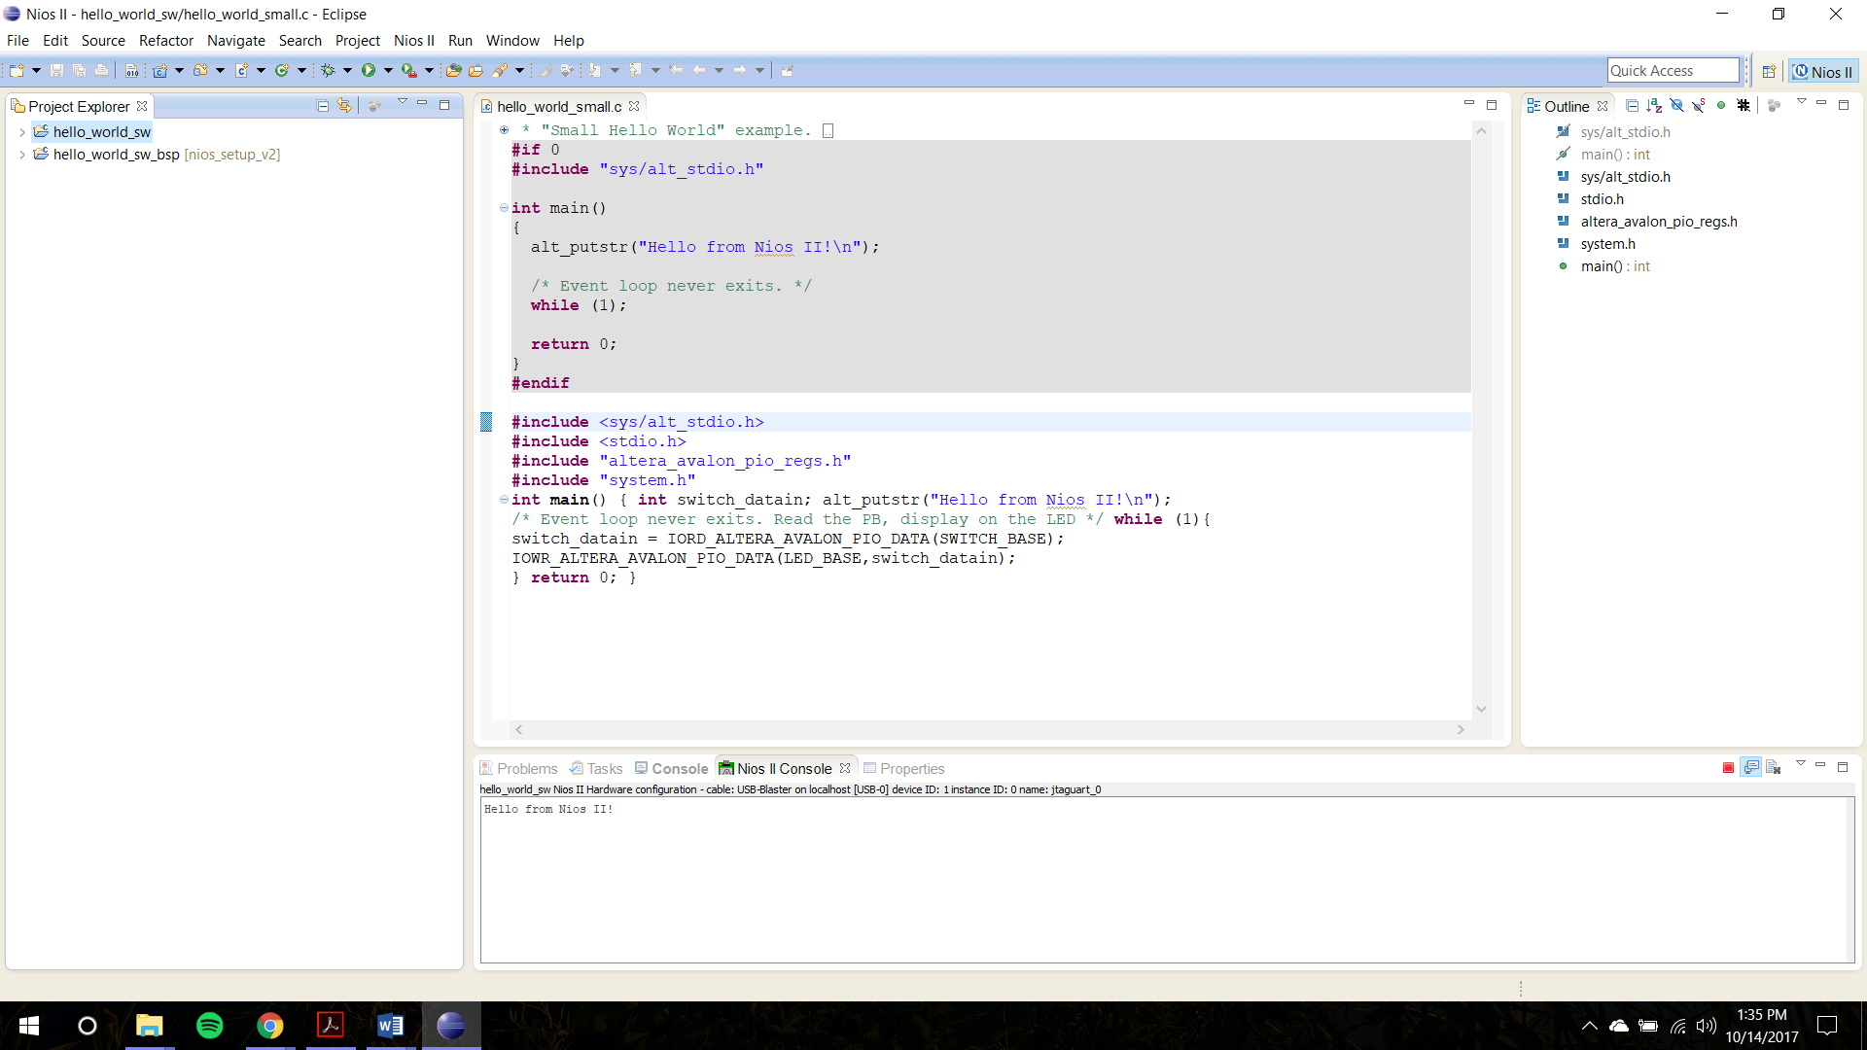

Fig 10. Successful output displayed in the console

**Demo part:**

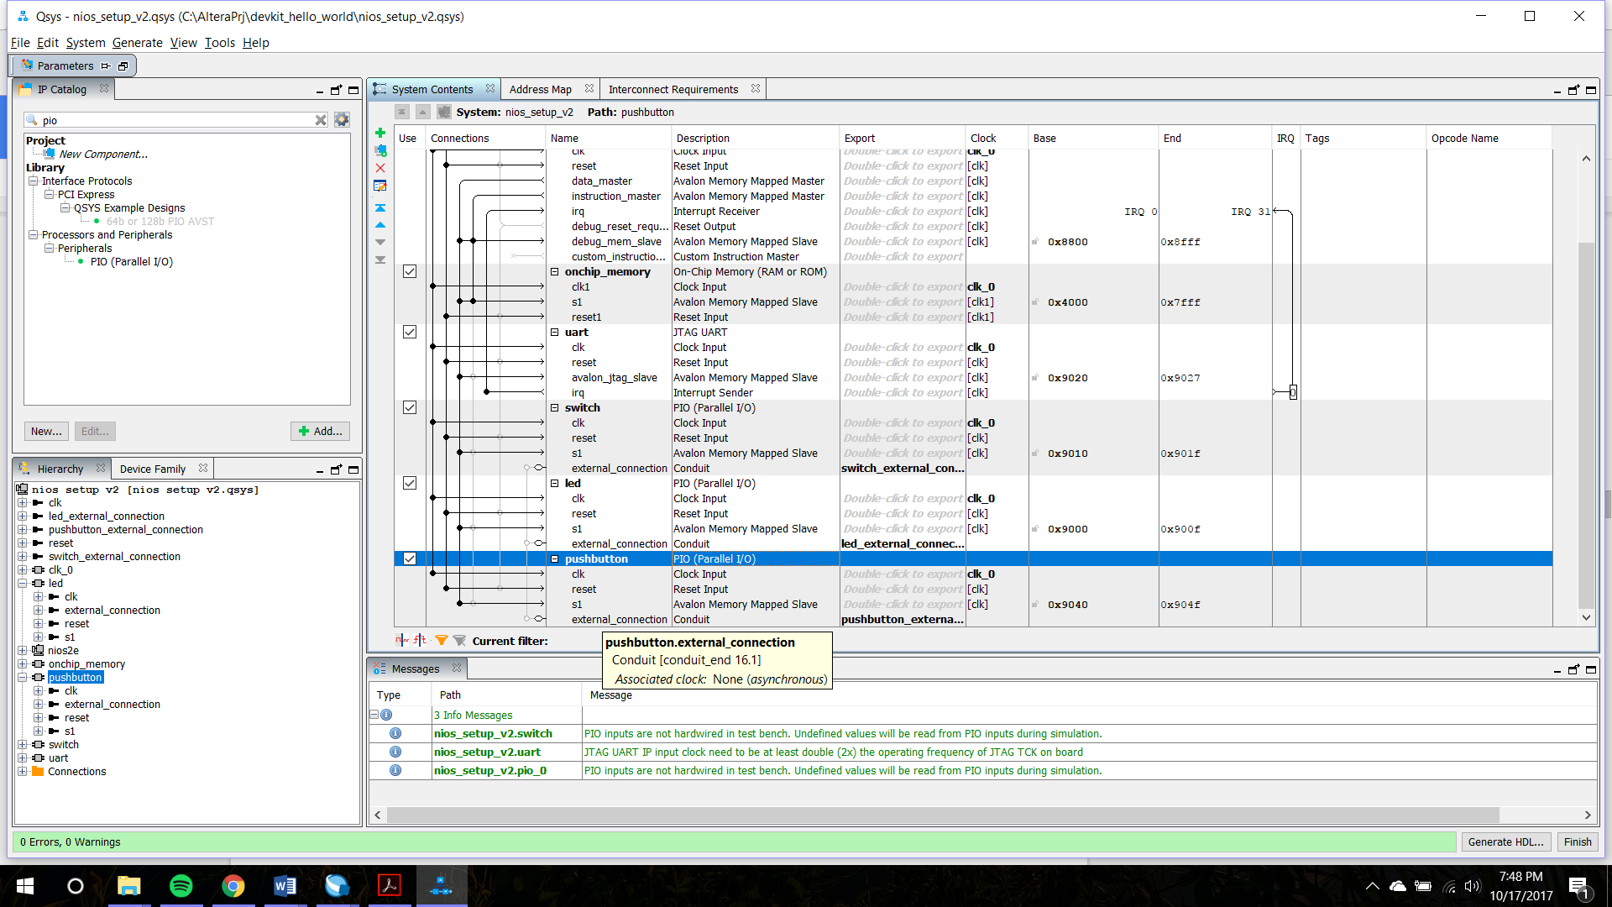

Fig 11. Qsys for the Demo

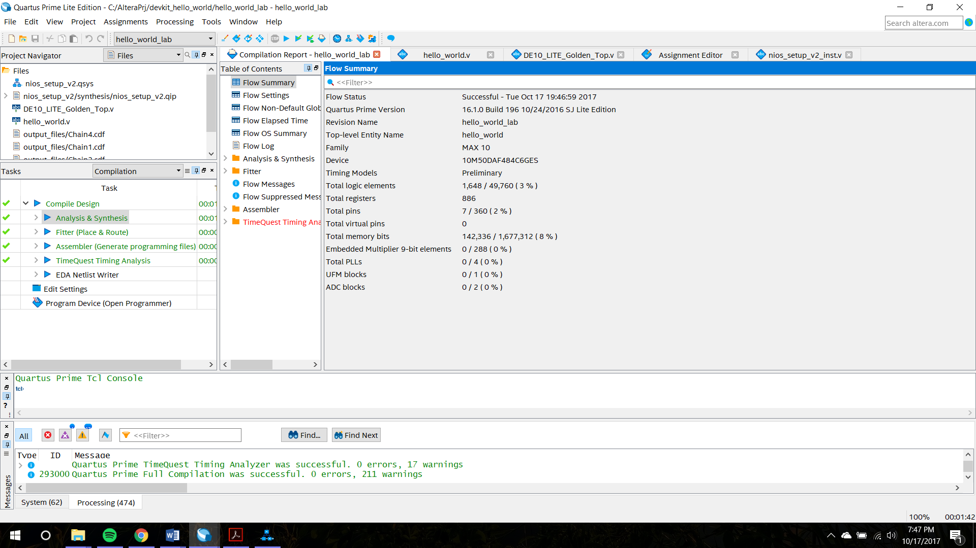

Fig 12 Compilation report for the demo

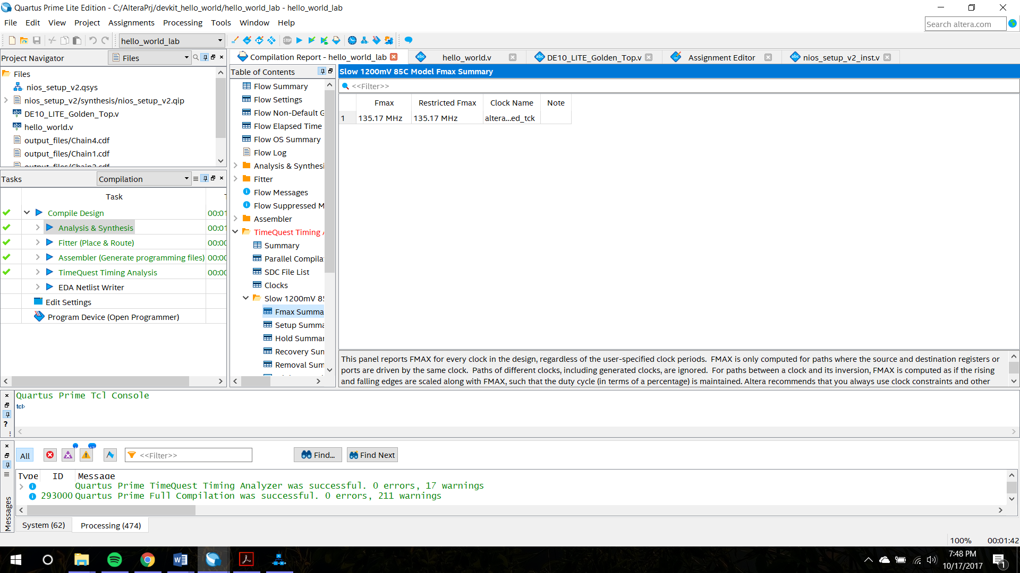

Fig 13 Fmax of the demo

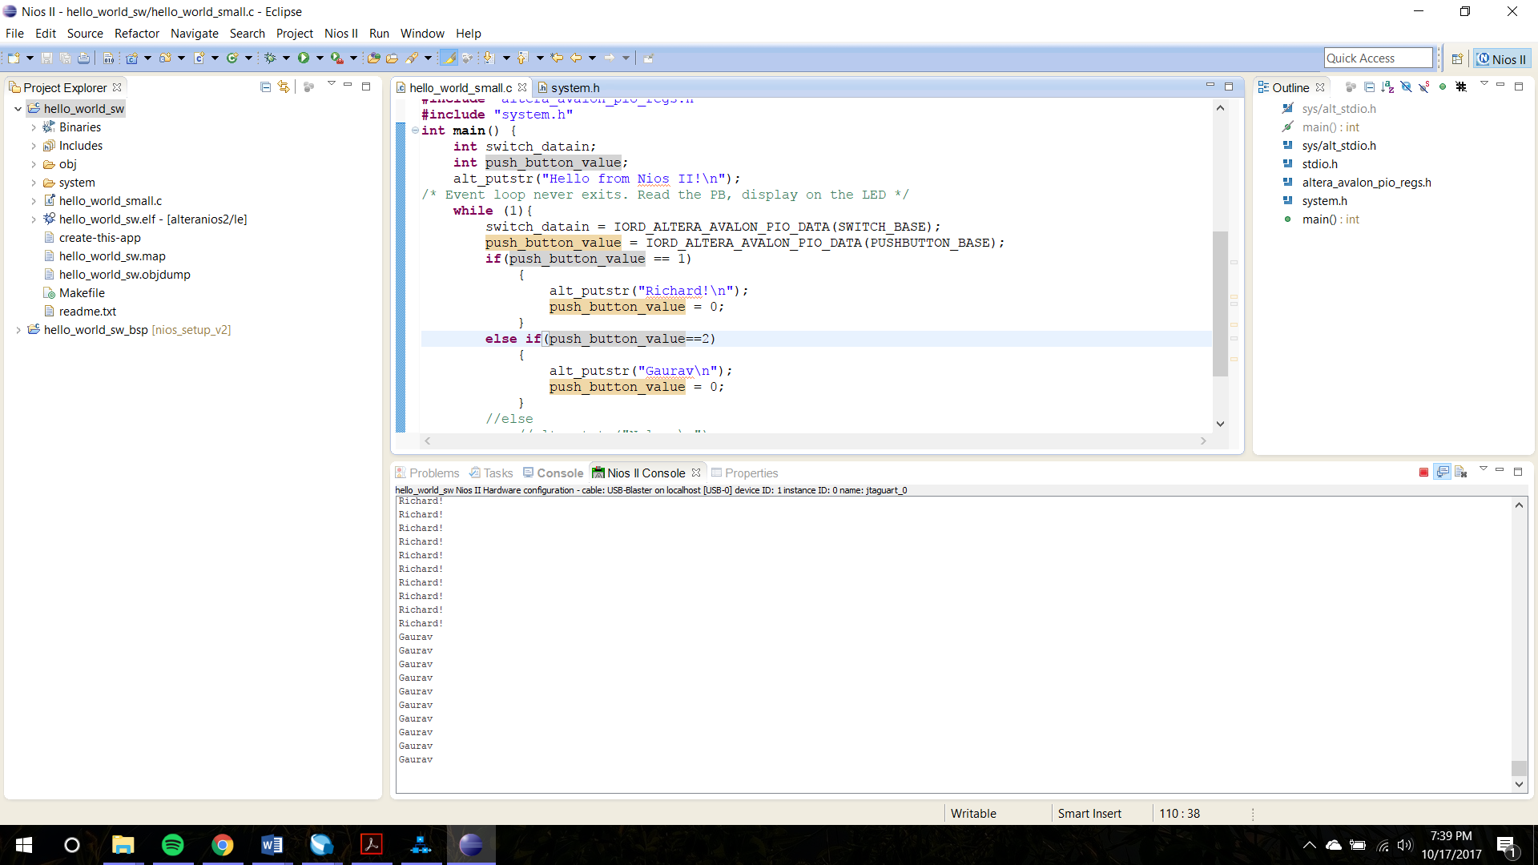

Fig 14. Successful output of the demo

**Module 3**

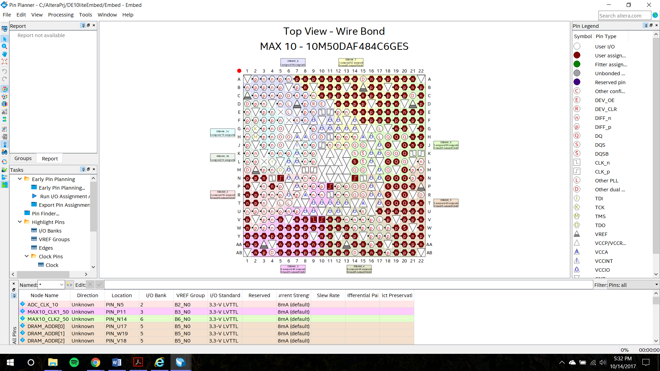

Fig 1. Wire bond view of the DE10Lite

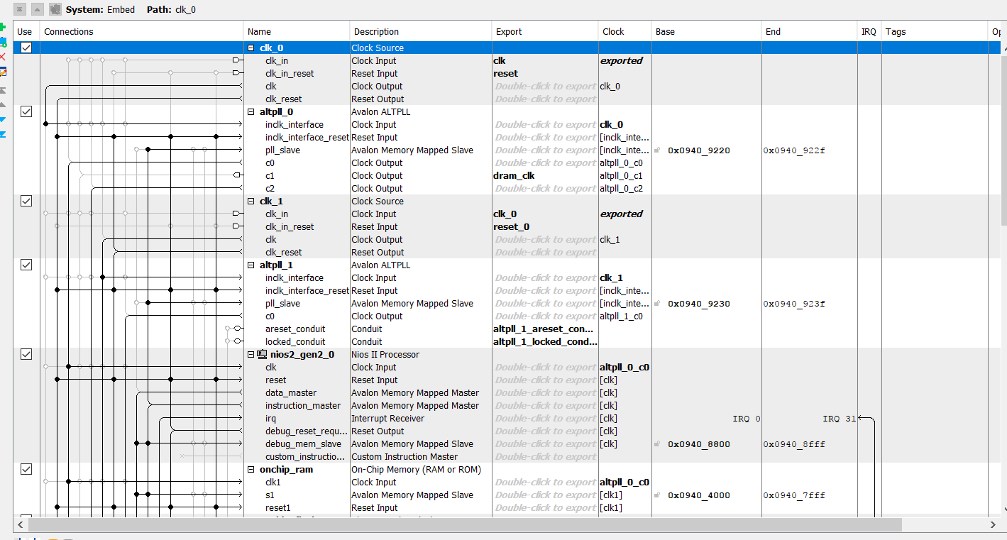

Fig 2. QSys for module 3

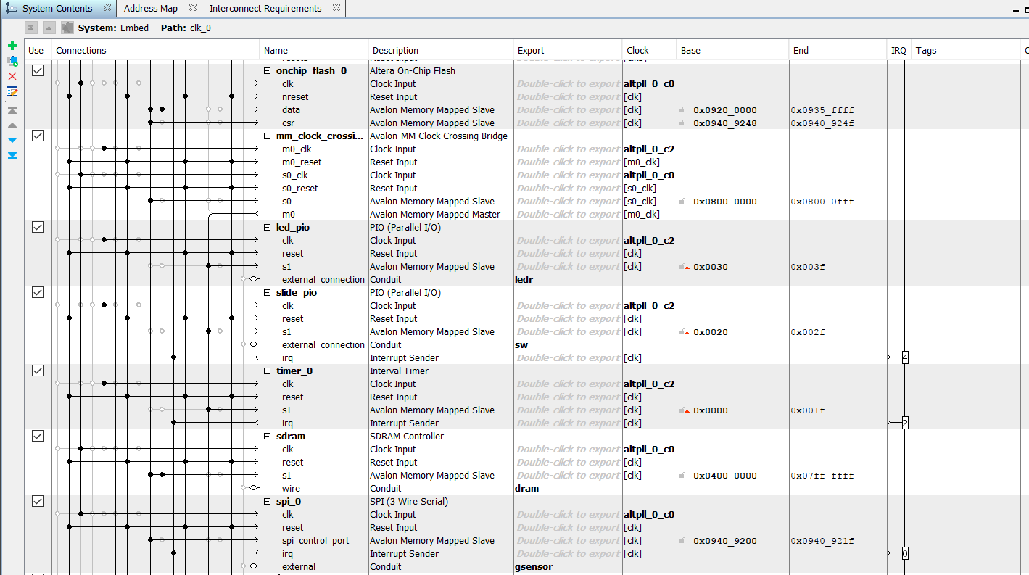

Fig 3. Qsys for module 3

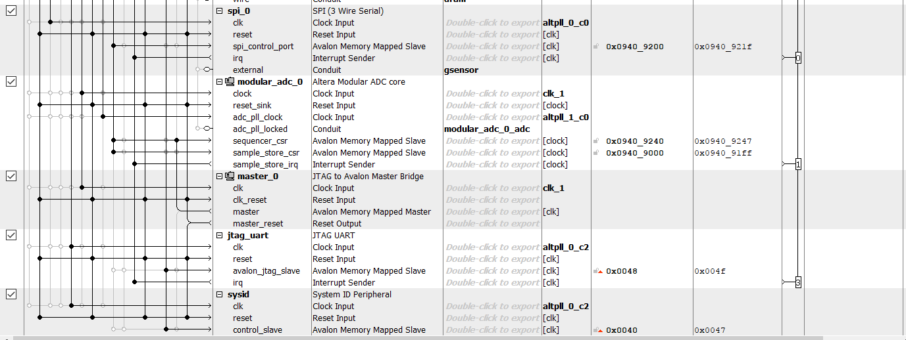

Fig 4 Qsys for module 3

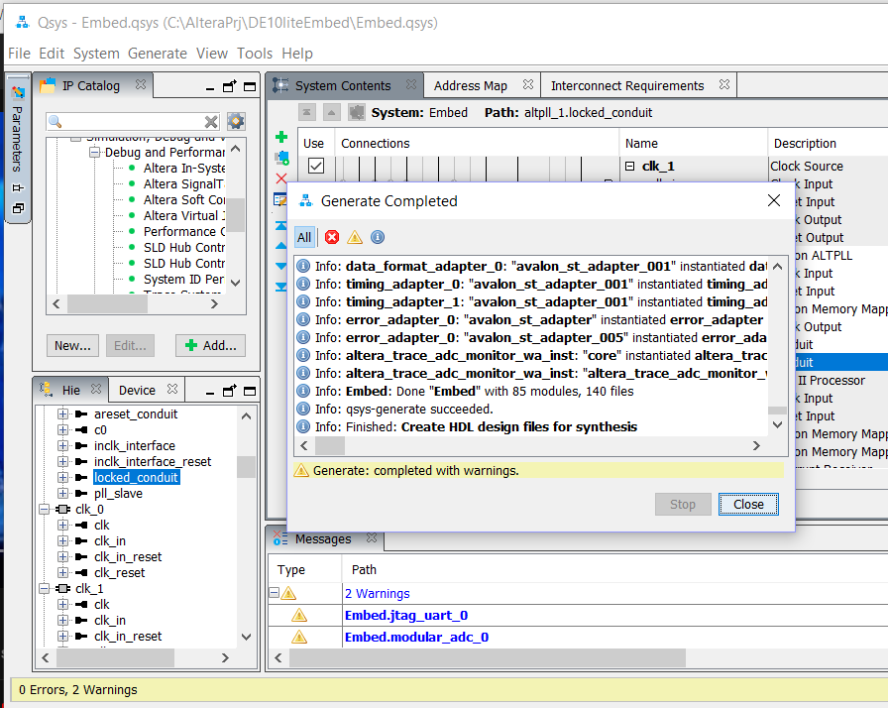

Fig 5. Successful generation of the HDL from Qsys

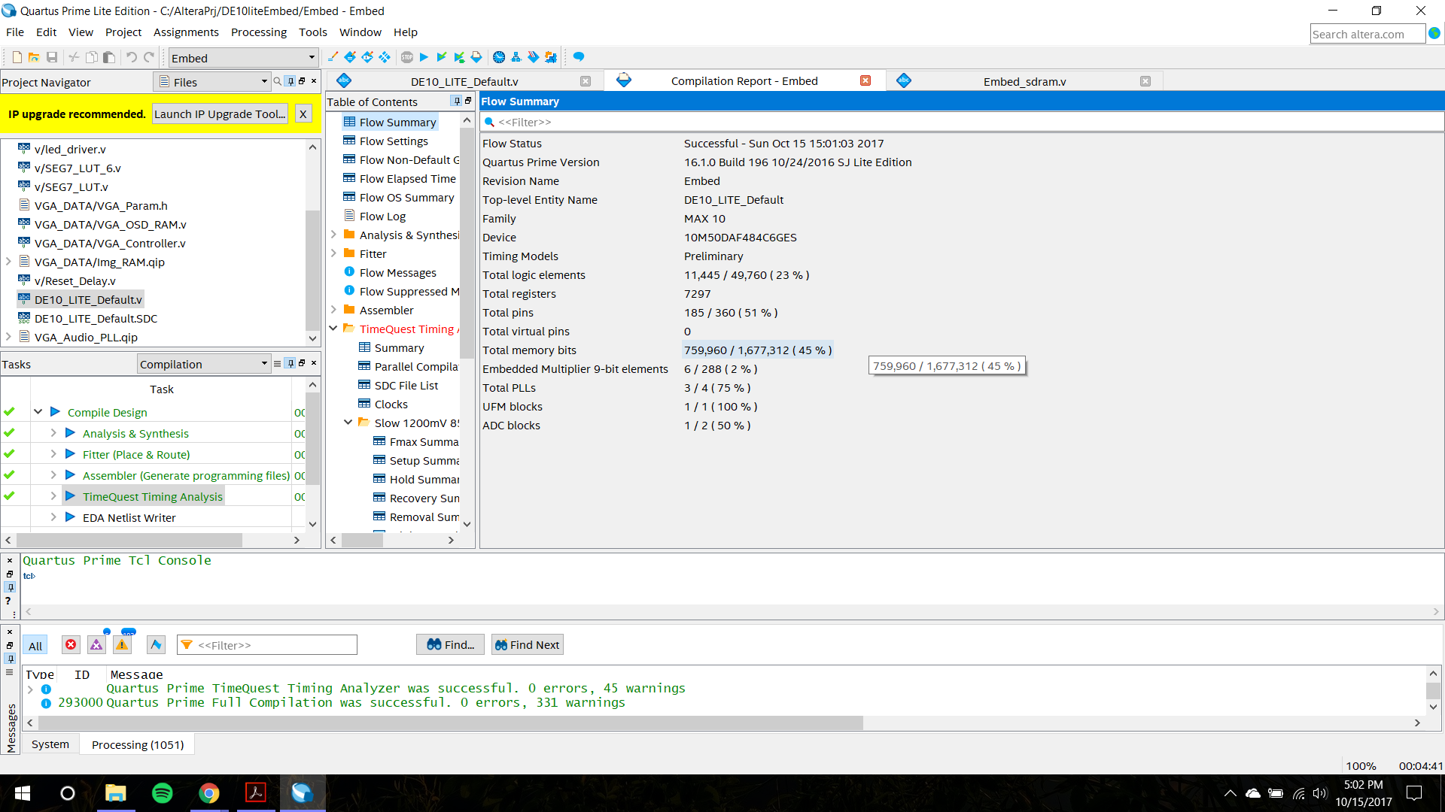

Fig 6. Compilation report for Module 3

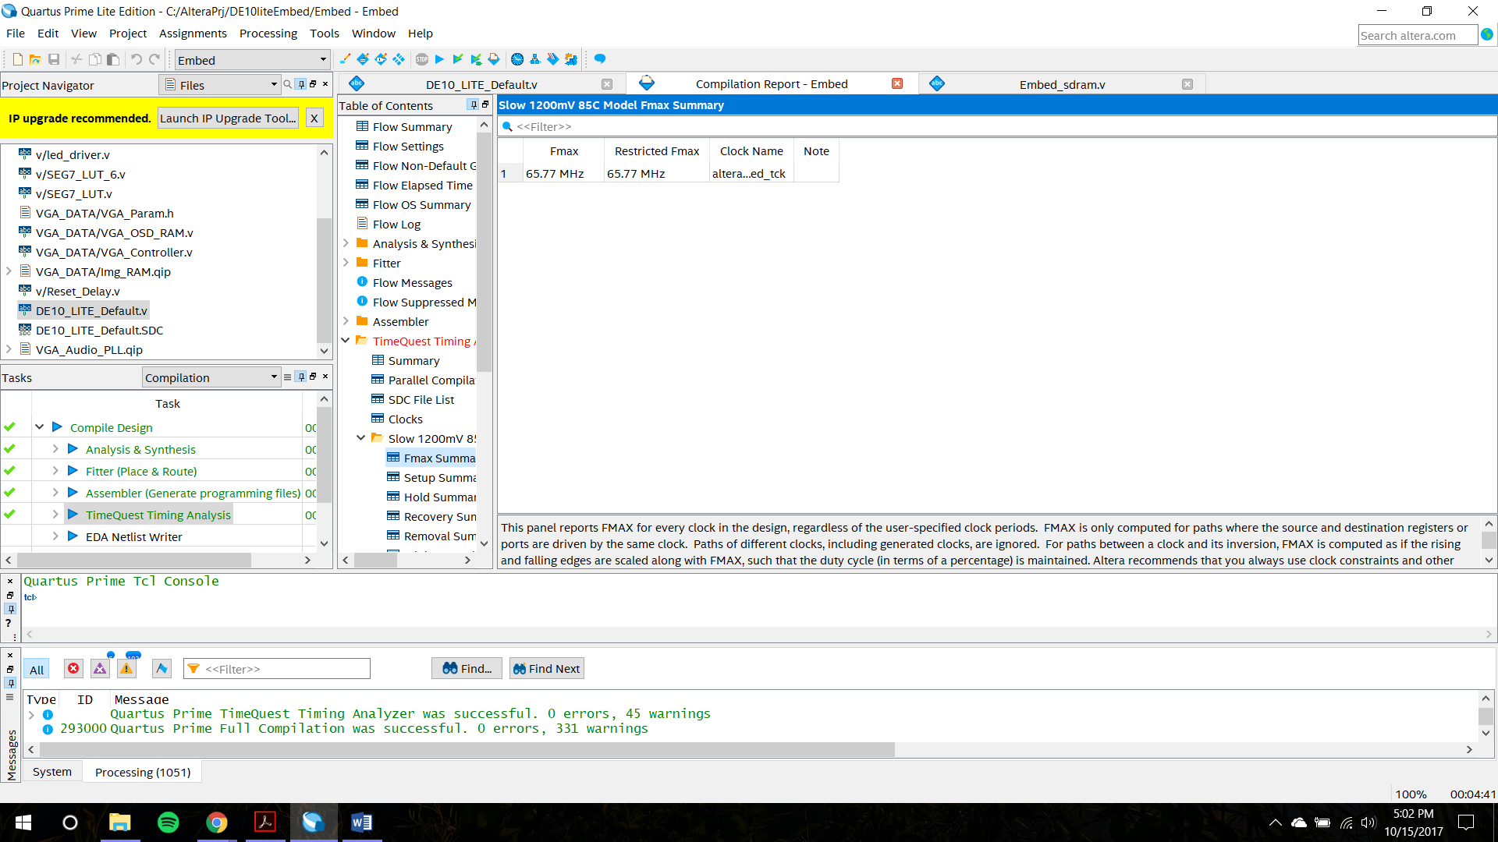

Fig 7. Compilation report for Module 3

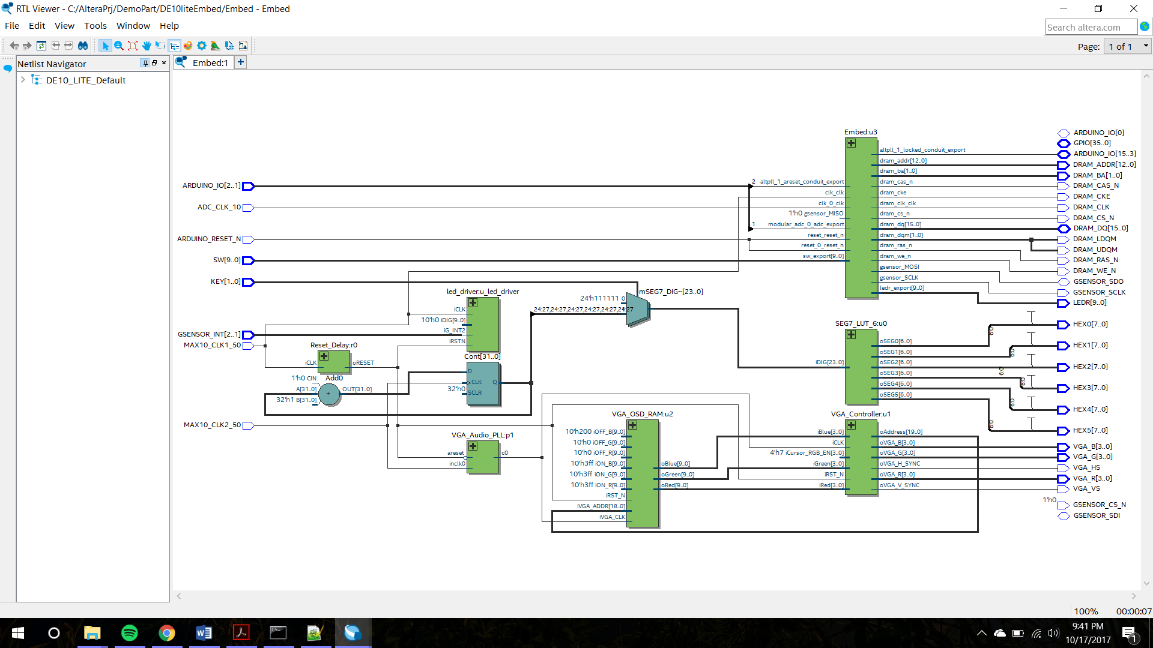

Fig 8. RTL of the system

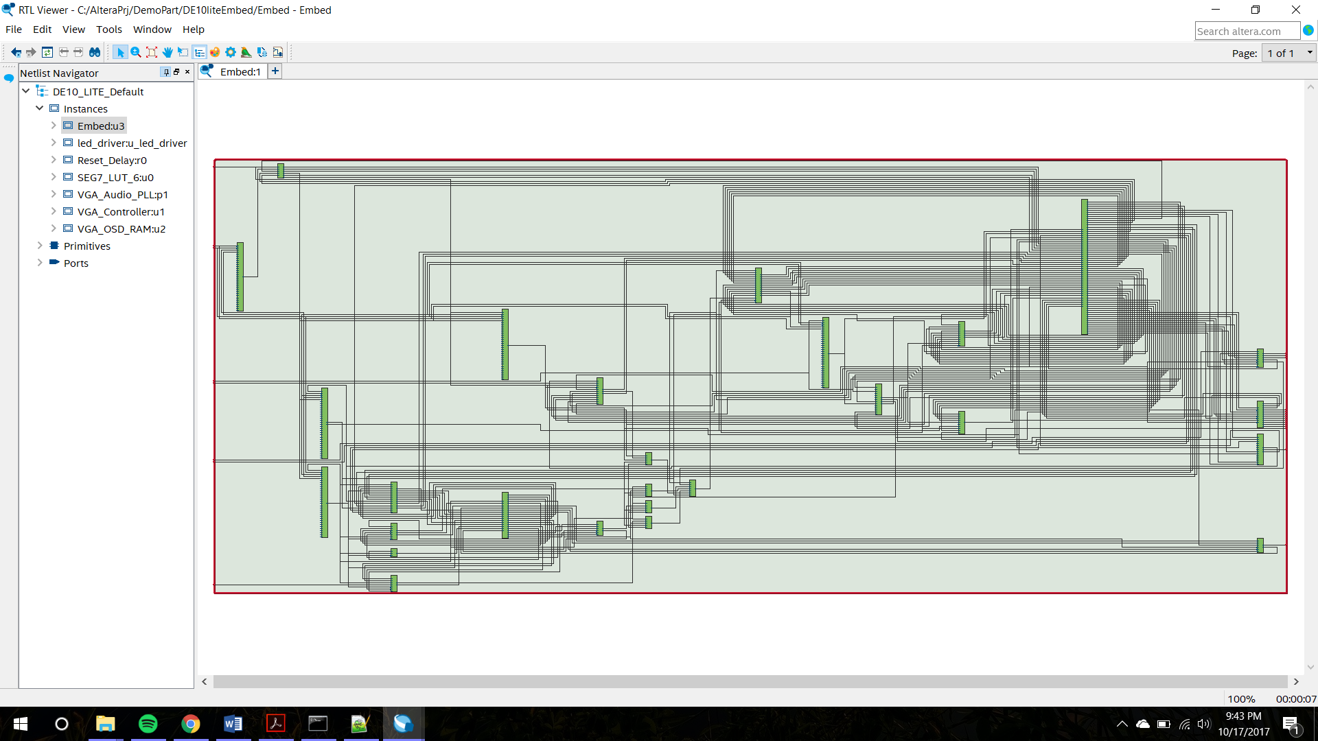

Fig 9. The NIOS II soft processor

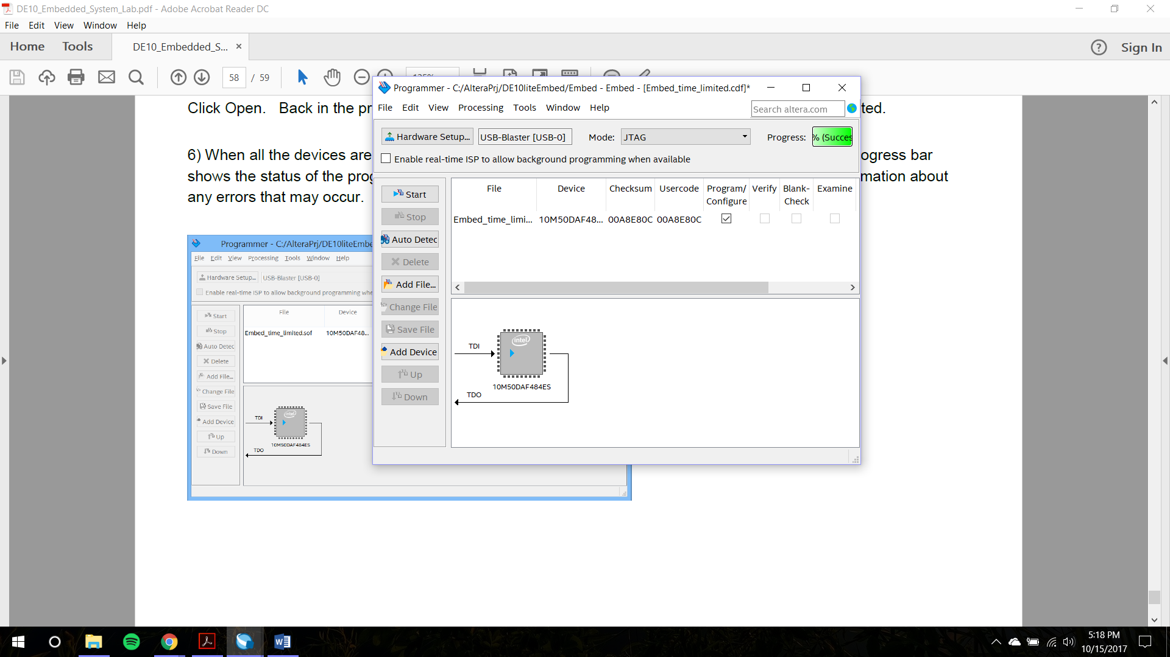

Fig 10. Successful programming of the De10Lite

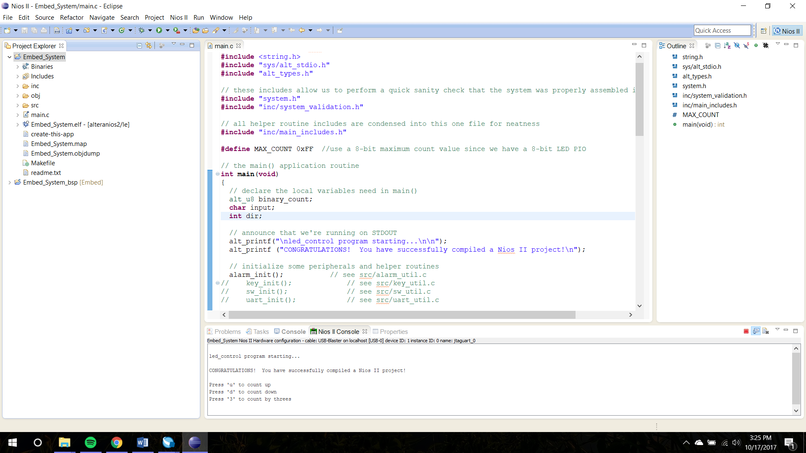

Fig 11. Successful output observed in the console

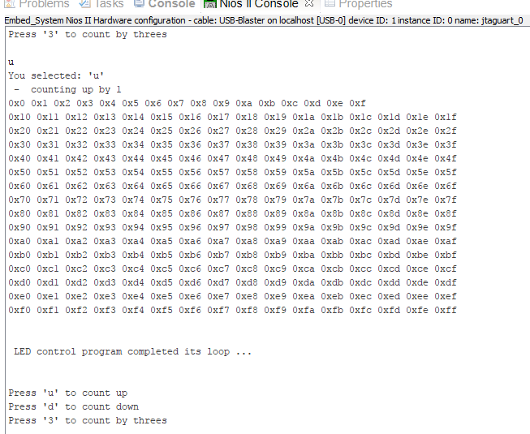

Fig 12. Output for the up counter

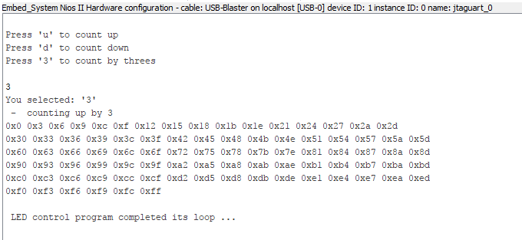

Fig 13. Counting by threes

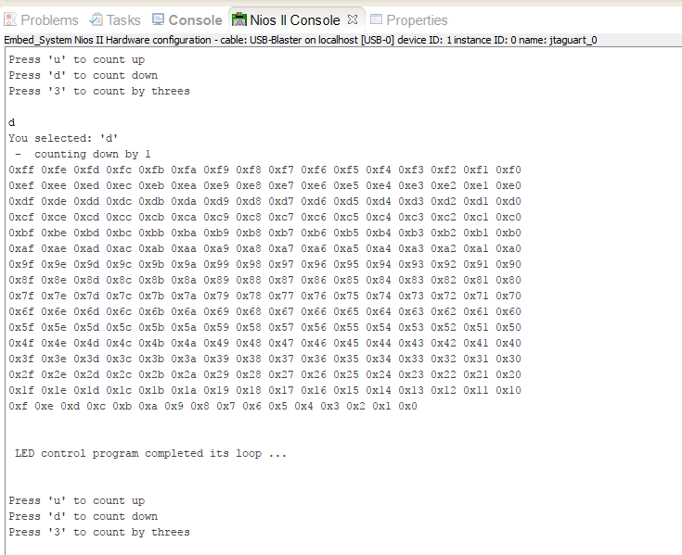

Fig 14. Downcounter

**Demo module 3**

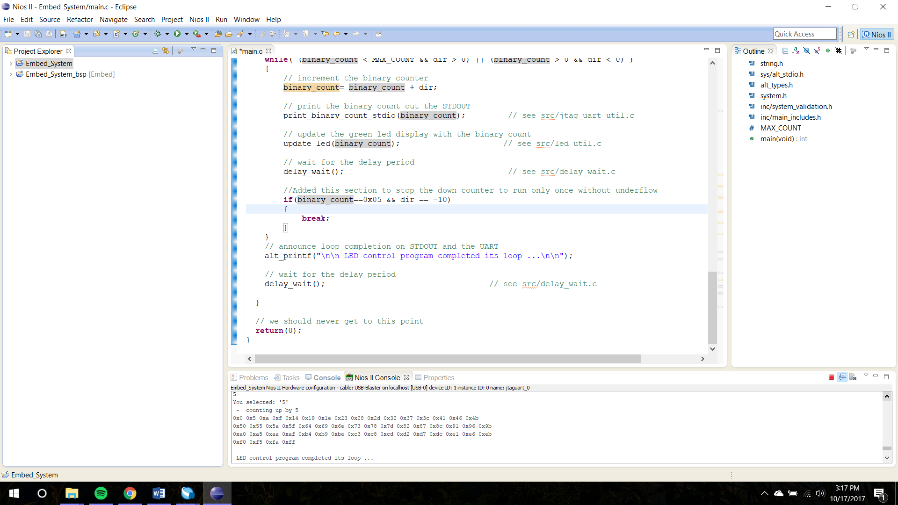

Fig 15 Up count by 5

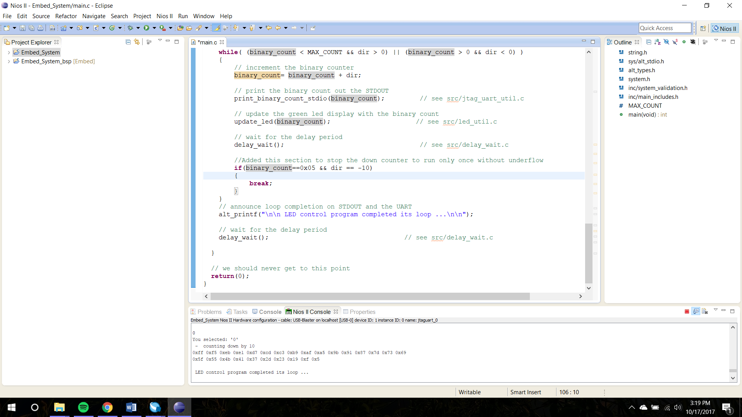

Fig 16. Down count by 10